ACCESS CONTROL
What
Access Control Lists (ACLs) are used in ServiceNow to control who can access records and fields within an application.
When the custom Network Database table was created, ServiceNow automatically generated the default ACL records associated with the table. For this implementation, the default ACL configuration is retained and used to control access to the table and its data.
The access-control mechanism provides a security layer for protecting network request information from unauthorized access or modification.
Why
Network-related requests may contain information that should only be accessible to authorized users and support personnel.
Access control is therefore required to:
- Prevent unauthorized users from accessing network request data.
- Control who can read or modify records.
- Protect sensitive request information.
- Support role-based access.
- Maintain organizational security and governance.
- Ensure that users receive only the level of access appropriate to their responsibilities.
How
Activity 1 – Default ACL Creation
When the custom Network Database table is created, ServiceNow automatically generates the default ACL records associated with the table.
For this project:
The automatically generated default ACLs are used without creating additional custom ACL rules.
The default ACLs provide the baseline access-control mechanism for the custom table.
Activity 2 – Verify ACL Configuration
- Navigate to:
All → System Security → Access Control (ACL)
- Search for ACLs associated with the Network Database table.
- Review the automatically generated ACL records.
- Verify the applicable operations, such as:
  - Create
  - Read
  - Write
  - Delete
- Confirm that the existing/default configuration is being used as required by the project.
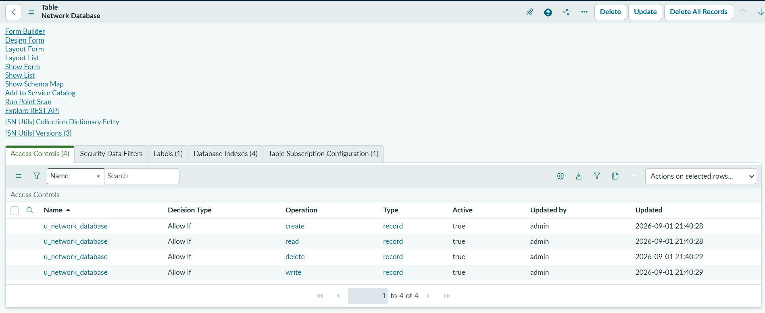

Outcome
The Access Control configuration establishes the security foundation for the Automated Network Request Management solution.
The project uses the default ACLs automatically generated for the custom Network Database table, providing baseline control over access to its records and data.
This helps ensure that network request information is accessed and modified only by appropriately authorized users.
Replicability Note
No additional custom ACL rules were created for this implementation. The default ACLs generated when the custom table was created were retained. If future requirements introduce more restrictive field-level or role-specific access, additional ACL rules can be configured without changing the underlying data model.

